**Sample Paper- 2013**

**Subject: MULTIMEDIA AND WEB TECHNOLOGY**

**Class 12th**

* Please check that this question paper contains 5 printed pages.
* Code number given on the right hand side of the question paper should be written on the title page of the answer –book by the candidate.
* Please check that this question paper contains 7 questions.
* **Please write down the Serial number of the question before attempting it.**
* 15 minutes time has been allotted to read this question paper. The question paper will be distributed at 10.15 a.m. From 10.15 a.m. to10.30 a.m., the student will read the question paper only and will not write any answer on the answer script during this period.

*Time allowed : 3 hours] [Maximum Marks :70*

**a)** Define DBMS. Name any two software used to manage database. 1

**b)** Name the following: 1

i) A part of the Microsoft Office suite that is used to create and manage databases

ii) The MS-Access view in which we can define the fields, their data types and their input masks.

**c)** Latest Hit Station library stores data of all available DVDs on its server in a table named HitMovies in MS Access. HitMovies given below and answer the following questions:

TABLE : HitMovies

|  |  |  |  |  |
| --- | --- | --- | --- | --- |
| MID | MName | Director | ReleaseDate | Releasing Company |
| M01 | London Dreams | Vipul Shah | 10/08/09 | Joshua |
| M02 | Wake Up Sid | AyaanMukherjee | 19/08/09 | Trinayan |
| M03 | What’s Your Rashee | Ashutosh Gowariker | 18/08/09 | Harem |
| M04 | Aladdin | Sujoy Ghosh | 15/08/09 | Chahata |

i) Name the field which can act as the primary key in the table HitMovies. 1

ii) If the Release details of the movies has to stored in a separate table(named RELEASE) , then identify any two fields from the above table which should be included in the table RELEASE. 2

iii) What type of relationship exist between the table HitMovies and the newly created table RELEASE? 1

**d)** “Devesh Theatre Group” is developing an advertisement for one of its clients. The client has specified that the movie should be viewable on DVD players as well as on the internet. Also they want that the viewers should not have to download any special code to view the file. Keeping these requirements in mind, suggest the most suitable format from the following: 2

(i) AVI

(ii) MPEG

(iii) JPEG

Justify your choice.

**e)** What is the full form of MIDI ? 1

**f)** Differentiate between JPEG and GIF file formats. 1

1. **Questions given below are based on FLASH :**
2. Explain the usage of the following tools available in Flash 5. 2

i. Modifiers ii.Launcher Bar

1. Name four instances property ? 1
2. Explain the concepts of Frame, Frame Buffer and Frame Rate. 1
3. What is the extension of following file format 1
   * 1. Macintosh Projector ii. Quick Time
4. How exporting a movie is different from Publishing a movies? 2
5. Observe the official timline of events for Curiosity's landing and do as directed : 3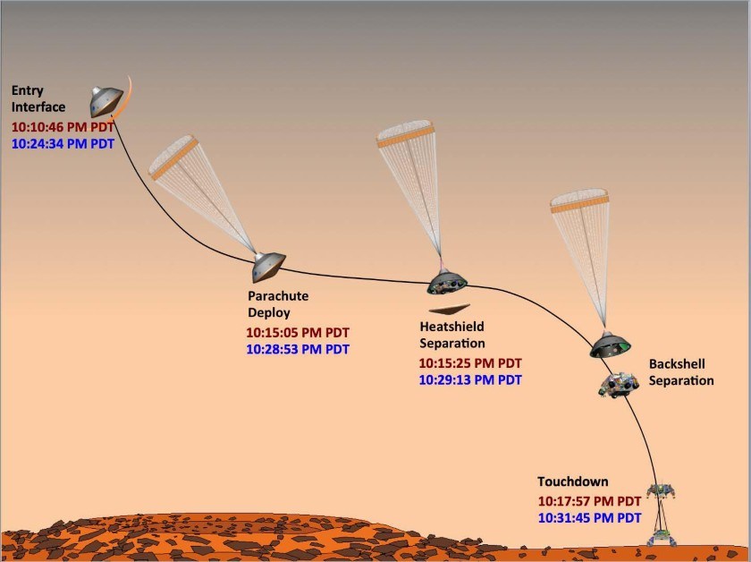

* The image on the left hand top side shows the position and size of the image for frame1.
* The image on the right hand base side shows the position and size of the image for frame 40.
* The line shows the path of motion of the Curiosity.

Write the procedure and property settings for animating the above scenario. Ignore all the images between frame 1 and frame 40.

1. **Questions given below are based on HTML :**

**a)** Name any two implicit tag that can be used in place of <B> and <I> tags . 1

**b)** What is the use of # sign in intra file linking in HTML? 1

**c)** Write the HTML code to generate a Web Page in the format given below : 8

Consider the following while writing the HTML code

1*.* Background color of the page should be “Magenta”, text color should be “Maroon” .

2. Title of the page is “CBSE new attempt”.

3. Text color of main heading on the page should be “Blue”.

4. Font face of text in the page should be “Arial”.

5. Picture used in the page is the file “class12.jpg”.

6. Use the concept of list .

7. Pages linked to :

*Multimedia--m.html , Internet--int.asp , Vedioconferencing--ve.avi , Animated courses--ac.jsp*

8. [multimediaandwebtech@aol.com](mailto:multimediaandwebtech@aol.com) mail id should be linked properly.

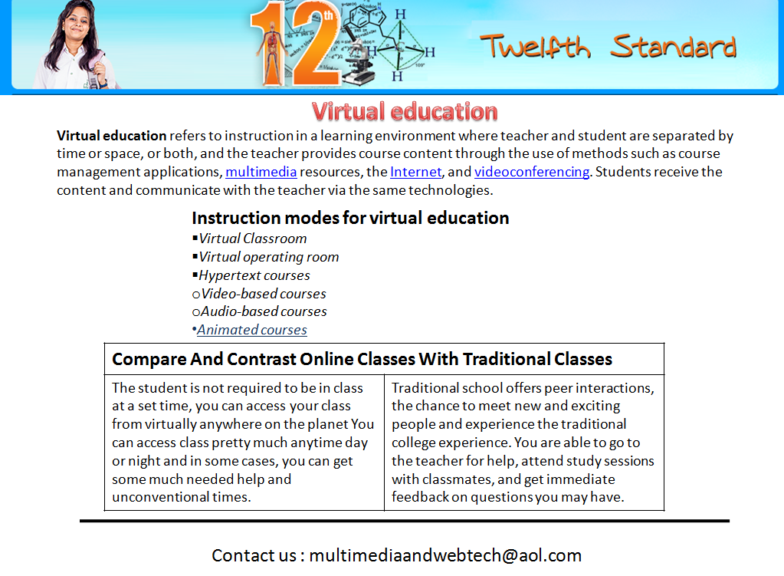

**4. Question given below are based on ASP :**

1. Name any two technologies that are equivalent to ASP. 1
2. What is the importance of GETAdvertisement method of ADrotator component ? 1

**c)** Identify the following: 2

(i) The collection used to retrieve the values of form elements sent using the GET method.

(ii) The alternate command for <% response.write(”HELLO”) %>

**d)** Use the following script to answer the questions that follow: 2

<%

DIM X

Sub result()

SID

Y = 20

SID

END SUB

SUB SID

X=X+5

END SUB

%>

(i) What is the scope of variable X and Y in the above script?

(ii) How many times will the subroutine *SID* be executed in the above script?

**e)** Observe the following script: 1

<SCRIPT LANGUAGE = “VBSCRIPT” RUNAT=”SERVER”>

OPTION EXPLICIT

DIM A, B

A=0;B=1

Do while I <= 5

C= A*B

RESPONSE.WRITE C

A=B

B=C

LOOP

</SCRIPT>

Everytime this script is executed, the programmer receives an error as soon as the DO WHILE is reached. Identify the error and write the corrected code.

**f)** Find output 3

1. Response.write( LTRIM(LEFT(“SAARC MODEL CONFERENCE” , 7)))
2. Response.write(ucase(mid(“Park Mediclaim”,2,abs(15 mod 4))
3. Response.write(instr(“A Govt. of India undertaking” , “nd”)

**5. Question given below are based on ASP :**

**a)** Observe the program segment given below carefully and fill the blanks marked as Line 1 and Line 2 using methods of the RecordSet object for performing the required task.3

<%

DIM objConn, strConn, objRS

SET objConn = Server. CreateObject(“ADODB.Connection”)

strConn = “DSN=exam”

objConn. Open strConn

SET objRS = Server.CreateObject(“ADODB.RecordSet”)

objRS.Open “Student”, objConn, 2, 2

objRS.MoveLast ‘Move the cursor to the end of file

______________ ‘Line 1 to Add a new blank record

objRS(“AdmNo”) = Request.Form(“AdmNo”)

objRS(“Name”) = Request.Form(“Name”)

______________ ‘Line 2 to save the record in the database

objRS.Close

objConn.Close

SET objRS = Nothing

SET objConn = Nothing

%>

1. Find the output of the following ASP coding 2

<html>

<body>

<%

s=”mistrust or distrust”

m=len(s)

for k =1 to m step 2

n=mid(s, k,2)

response.write (n)

response.write (“<br>”>

next %>

</body>

</html>

1. Convert the following coding in to do while ------loop 2

<html>

<body>

<%

s=array(12,45,87,54,90,76)

max=ubound(s)

for I = max to 1 step -2

s(I) = 10*s(I)

response.write (s(I) & “<br>”)

next %>

</body>

</html>

1. Write ASP code to read the contents of file and print the count of the word “the” as an independent word in a text file “story.txt”.

For example , if the content of the file story.txt is 3

There was a monkey in the zoo. The

Monkey was very naughty.

Then the output of the program should be 2.

**6. Question given below are based on VBScript :**

**a**) Define the term event. Name the events to be used in the following situations: 2

(i) To display a message every time the viewer closes a web page.

(ii) To deactivate a particular textbox in a form

**b**) Give the output for the following script code: 2

<Script Language="VBScript">

B=10

D=12

C=A+B+C+D

For A=1 to 12 step 5

Document.Write(D)

B=B-1

C=A+B+C+D

D=D+1

Document.Write(C)

Next

</Script>

**c)**Find the errors and rewrite the correct code : 2

<Script =”VBScript”>

Dim w,o,r,k

w = 1

o = 10

for r= w to o step goto 2

Document.read(A+B)

w = w / 2

o = o * 9

Document.write(w+o+r+k)

Loop

</Script>

**d)** Write the HTML code for creating the form given below and also write the embedded VBScript code for the click event of the submit button. 4 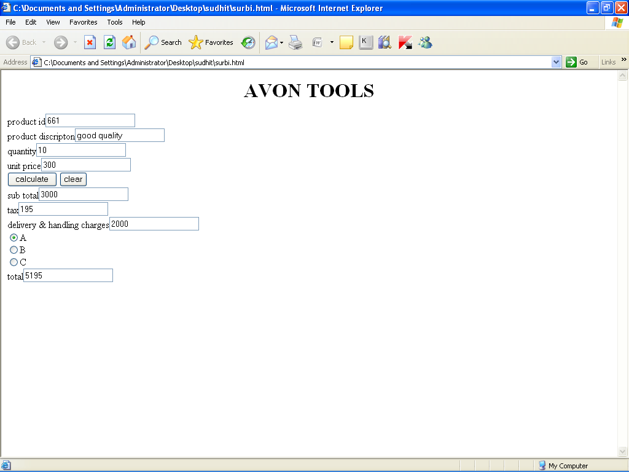

**7. Question given below are based on Network and OSS :**

1. Write a short note on ARPANET. 1
2. Define RJ45 Connector. 1
3. Write short notes on PPP. 1
4. Write short notes on the following Channel Allocations (Wireless/Mobile Comunication) 1
5. GSM
6. What do you mean by Open Source Software ? What are the conditions required for the Open Sources software ? 1
7. Define Localisation. 1
8. ProActor School of acting in Mumbai is setting up the network between its different wings. There are four wings named as SENIOR(S), JUNIOR(J),ADMIN(A), and HOSTEL(H). 4

***The distances between the different wings are given below :***

Between A and S 100 mts.



Between A and J 200 mts.

Between A and H 400 mts.

Between S and J 300 mts:

Between S and H 100 mts.

Between J and H 450 mts.

Number of computers in each wings is as given below:

***Wing No. of Computers***

WING A 10

WING S 200

WING J 100

WING H 50

Answer the following questions based on the above given information:

1. Suggest the most suitable topology for connecting these wings.
2. Suggest the most suitable place to house the server. Justify your choice.
3. Where and why should repeaters be used?
4. The second branch of the school situated in a hilly region is to be linked with its headquarters in Mumbai. Suggest the most economical way to connect it. The organization is ready to compromise on the speed of connectivity.

*****